**Chapter 5**

**Report on Present Investigation**

* 1. **Proposed System**

According to international labor organization (ILO) every year more than 2.3 million people die while working with heavy machinery.

To overcome this serious issue, we have developed a system is called as “motion controller” which sometimes is also referred as Mo-cap. A “motion controller” device is input device which takes input from real world in the form of physical, electrical or visual format by using appropriate sensors. This model will act as a controller to that particular heavy-duty machine.

**5.1.1 System Architecture**

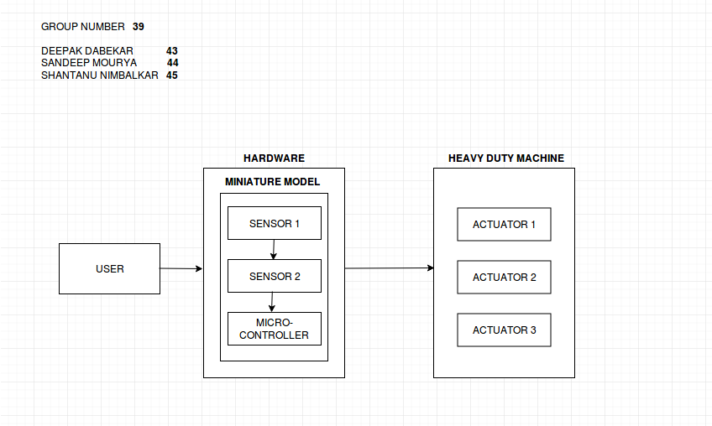

Fig.5.1 System Architecture

**5.1.2 Circuit Diagram**

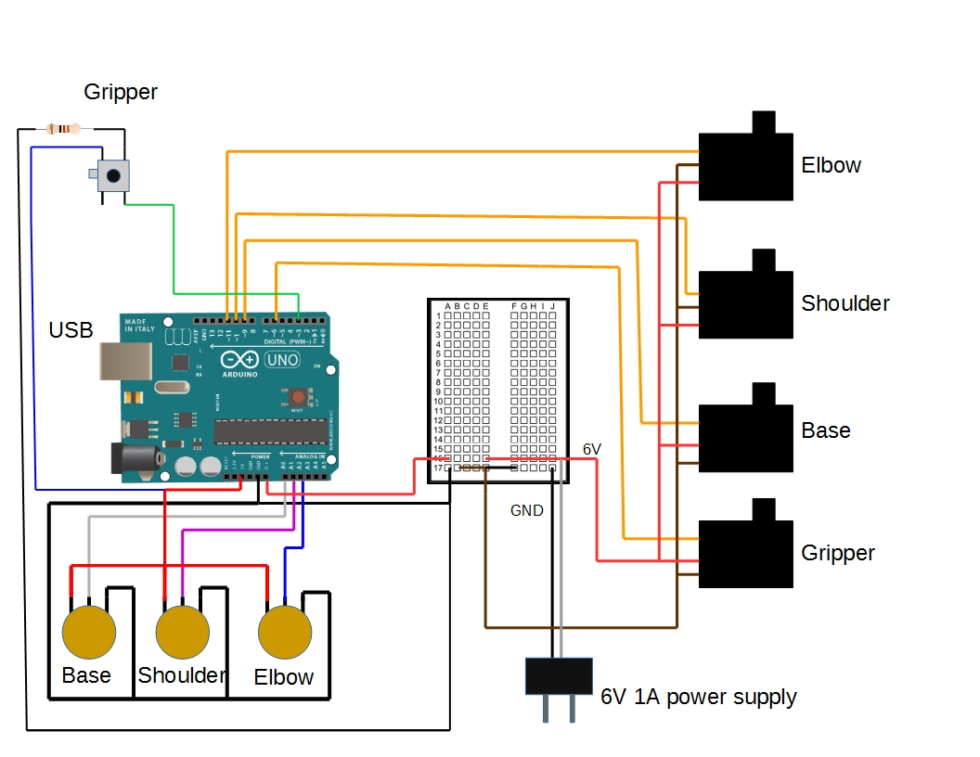

Fig. 5.2 Sequence Diagram